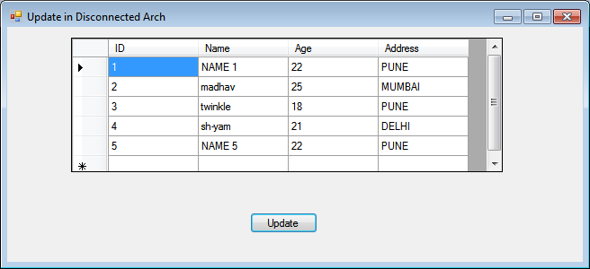

Imports System.Data

Imports System.Data.SqlClient

Public Class Form1

Private conn As SqlConnection

Private daStudent As SqlDataAdapter

Private dsStudent As DataSet

Private Const tableName As String = "Student"

Private Sub Form1_Load(ByVal sender As System.Object, ByVal e As System.EventArgs) Handles MyBase.Load

conn = New SqlConnection("Data Source=.\SQLEXPRESS;AttachDbFilename=C:\Users\admin\Documents\Visual Studio 2010\Projects\ADO\myDB.mdf;Integrated Security=True;Connect Timeout=30;User Instance=True")

dsStudent = New DataSet()

daStudent = New SqlDataAdapter("SELECT * FROM Student", conn)

Dim cmdBldr As New SqlCommandBuilder(daStudent)

daStudent.Fill(dsStudent, tableName)

dgStudent.DataSource = dsStudent

dgStudent.DataMember = tableName

End Sub

Private Sub Button1_Click(ByVal sender As System.Object, ByVal e As System.EventArgs) Handles Button1.Click

daStudent.Update(dsStudent, tableName)

MsgBox("Update done", MsgBoxStyle.Information)

End Sub

End Class